POLI316 Fall 2021 Midterm Exam
Professor Sanghoon Park
Instruction:
This midterm exam is a closed-book/note in-class exam. You have 75 (seventy-five) minutes to finish this exam, which will be from 4:25 pm to 5:40 pm. There are 48 (forty-eight) questions as a total. The exam consists of 25 (twenty-five) multiple-choice questions, 10 (ten) true/false questions, 10 (ten) fill-in-the-blank questions, 1 (one) short answer question, and 2 (two) bonus credit questions. Each multiple-choice and T/F question is worth 2 (two) points, and each fill-in-the-blank question is worth 2.5 (two point five) points. A short answer is worth 5 (five) points. The total points for the midterm exam are 100 (hundred). The midterm exam also includes two bonus credit questions worth 3 (three) points each. There is only one correct answer for each question.

Part I. Multiple-Choice Questions

- A valid argument is
- one where the conclusion is true.
- one where the conclusion is false.
- one where you have to accept the conclusion if you accept the premises.
- one where you do not have to accept the conclusion if you accept the premises.
- None of the above.
Ans: D

- A falsifiable statement means that
- the statement is not scientific.
- the statement is wrong.
- the statement is potentially testable.
Ans: C

- According to the discussion in Chapter 2, it is possible for scientists to draw valid inferences from Mill’s Methods of Agreement and Difference only if
- the causal process is deterministic.
- all the potential causes have been identified.
- there is a single cause of the outcome.
- none of these.
- all of the assumptions listed must hold.
Ans: E
- Lijphart (1971) compares three different methods of experiments, statistics, and comparative method. Which of the following is not correct for Lijhpart (1971)?
- All of these methods seek to produce scientific explanations.
- Experimental method is the most nearly ideal method for scientific explanation.
- Statistical method is a method to discover perfect relationships among variables.
- Comparative method has the same logic of the experimental or statistical method except number of cases.
- None of the above.
Ans: C

- Przeworski and Teune (1982) compare the two different comparative strategies: the Most Similar System Designs (MSSD) vs. Most Different System Designs (MDSD). Which of the following is not correct?
- The MSSD is based on the belief that systems as different as possible with respect to as many features as possible constitute the optimal samples for comparative inquiry.
- The MSSD is also called as maximum strategy in comparative methods.
- The initial assumption of the MSSD is that individuals were drawn from the same population.
- In the MSSD, we can consider that systemic factors do not play any role in explaining the observed behavior.
- None of above.
Ans: A

- Przeworski and Teune (1982) compare the two different comparative strategies: the Most Similar System Designs (MSSD) vs. Most Different System Designs (MDSD). Which of the following is not correct?
- In the MDSD, differences are ignored by intention, and similarities are explained.
- The MDSD finds the population of units at the lowest level observed in the study, most often political institutions.
- For the MDSD, the question of at which level the relevant factors operate remains open throughout the process of inquiry.
- In the MDSD, we eliminate factors differentiating social systems by formulating statements that are valid regardless of the systems within which observations are made.
- None of above.
Ans: B

- Why does Tilly describe the state as a protection racket?
- because the state promises to protect the citizens
- because the state falsely promises to protect the citizens
- because the state promises to protect the citizens from dangers that it poses to them
- because he is referring to dictatorial states
Ans: C

- Who suggested the following definition of states?
“A state is an organization with a comparative advantage in violence, extending over a geographic area whose boundaries are determined by its power to tax constituents.”

- Charles Tilly
- Max Weber
- Karl Marx
- Douglas North
- John Locke
Ans: D

Questions 9–11 go together.

- The Democracy-Dictatorship (DD) measure of democracy classifies a country as a democracy if (a) the chief executive is elected, (b) the legislature is elected, (c) more than one party competes, and (d) there has been an alternation in power. The Freedom House measure classifies a country’s level of “freedom” based on many criteria, including whether the government is accountable, the level of corruption, if minorities are autonomous, if people are treated equally under the law, if they have equality of opportunity, and so on. Say you had the following hypothesis: Governments are less corrupt in democracies than in non-democracies.
If you want your hypothesis to be falsifiable, which measure of democracy should you use?
- You should use Democracy-Dictatorship.
- You should use Freedom House,
- You could use either measure, and the hypothesis would be falsifiable.
- You should not use both measures.
Ans: A

- Say you had the following hypothesis: Democracies are more likely than dictatorships to join international organizations.
If you want your hypothesis to be falsifiable, which measure of democracy should you use?
- You should use Democracy-Dictatorship.
- You should use Freedom House.
- You could use either measure, and the hypothesis would be falsifiable.
- You should not use both measures.
Ans: C

- Say you had the following hypothesis: Citizens have greater equality of opportunity in democracies than in non-democracies.
If you want your hypothesis to be falsifiable, which measure of democracy should you use?

- You should use Democracy-Dictatorship.
- You should use Freedom House.
- You could use either measure, and the hypothesis would be falsifiable.
- You should not use both measures.
Ans: A

- Democracy-Dictatorship classifies countries as democracies or dictatorships. Their measure of democracy is a(n):

- ordinal measure of democracy.
- interval measure of democracy.
- nominal measure of democracy.
Ans: C

- Imagine that a scholar wants to develop a measure of pre-electoral coordination among parties in democracies. If she decides that she is most interested in whether two parties coordinate their electoral strategies at all versus both competing independently in an election, then is she conceptualizing pre-electoral coordination in terms of a dichotomy or a continuum?

- Dichotomy
- Continuum
Ans: A

- Imagine that the true value of economic inequality in country X is 4, on a scale from 1 to 10. Say four people code the level of economic inequality in country X using two different measures of inequality, A and B. Measure A yields values of 2, 3, 5, and 6. Measure B yields values 6, 6, 7, and 6. Is Measure A or Measure B a more reliable measure of democracy in country X?

- A is more reliable.
- B is more reliable.
- They are both equally reliable.
- None of them is reliable.
Ans: B

- Imagine that the true value of democracy in country X is 5. Say four people code the level of democracy in country X using two different measures of democracy, A and B. Measure A yields values of 3, 4, 6, and 7. Measure B yields values 6, 6, 7, and 6. Is Measure A or Measure B a more valid measure of democracy in country X?
- A is more valid.
- B is more valid.
- They are both equally valid.
Ans: A

- Classic modernization theory relies on an empirical association between income and democracy. The variant of modernization theory examined in Chapter 6 states that it is not income per se that encourages democracy but, rather, changes in the socioeconomic structure of a country that accompany development. The advantage of this variant of modernization theory is that it explicitly provides a causal mechanism linking economic development and democracy. Scholars testing this variant often continue to use a measure of income (such as gross domestic product (GDP) per capita) to represent the level of development. Why?

- because a country’s GDP per capita exactly measures the level of development of its socioeconomic structure.
- because a country’s level of GDP is generally a reasonable proxy (substitute) for the level of development of a country’s socioeconomic structure
- because there is no alternative to measure of income.
- None of above.
Ans: B

- Country X is characterized by the following features: it is wealthy, it has an abundance of natural resources, and its population is poorly educated. Country Y is characterized by the following features: it is wealthy, its economy is dominated by the financial service sector, and its population is well educated. Based on the variant of modernization theory that we examined, which country is most likely to be democratic?
- Country X
- Country Y
- None of above.
Ans: B

Questions 18 and 19 go together.

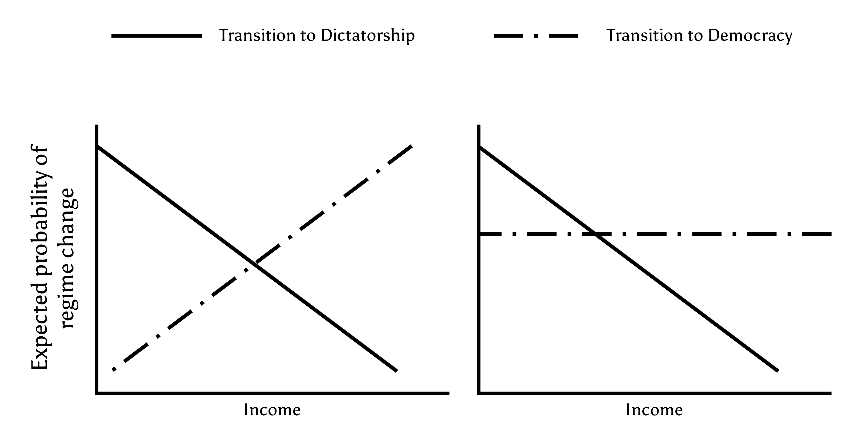
Figure 1. Explanations of Regime Change

- Look at Figure 1. Is Figure 1(a) or Figure 1(b) most consistent with classical modernization theory?
- Figure 1(a)
- Figure 1(b)
- None of above.
Ans: A

- Which of the following statement is not correct?
- Figure 1(a) predicts that countries are more likely to become and remain democratic as they become richer.
- Figure 1(a) assumes that when societies grow up, they’ll look like Western Europe and the United States.
- Figure 1(b) predicts that democracy is more likely to survive as countries develop and become richer, but it is not more likely to emerge.
- Przeworski et al. (2000) support Figure 1(b)
- None of above.
Ans: E

- “Economic growth increases government stability.” What is the dependent variable?
- economic growth
- government stability
- wealth
Ans: B

- Which of the following statement is not correct for Olson (1993)?

- Olson (1993) assumes that anarchic violence cannot be rational for a society.
- According to Olson (1993), a peaceful order emerges by voluntary agreement in small groups.
- Even in a large population, people have incentives to contribute to the provision of the collective goods.
- By Olson (1993)’s theory, the rational roving bandits settle down, wear a crown, and replace anarchy with government.
- None of above.
Ans: C

- A “public good” is:
- excludable and rivalrous.
- nonexcludable and rivalrous.
- excludable and nonrivalrous.
- nonexcludable and nonrivalrous.
Ans: D

- Which of the following statement is not correct for Olson (1993)?

- As rational stationary bandits are utility maximizers, they take entire income of their subjects through taxation.
- The rational stationary bandits can exact a larger amount of income if he leaves his subjects with an incentive to generate income.
- The rational stationary bandits provide public goods to increase taxable income.
- Government for larger groups normally arises because of rational self-interest among roving bandits.
- None of above.
Ans: A

- When dictators liberalize in an attempt to co-opt opposition groups, they are trying to strengthen their hold on power. If they miscalculate and assume that the opposition is weak when in fact it is strong, their liberalizing attempts might embolden the opposition groups and eventually lead to a democratic transition. But if the opposition group is actually weak, and the dictator mistakenly thinks it is strong, then the dictator will not dare to liberalize in the first place, which is unfortunate for civil society whose members could have benefited from the liberalization. If you were a member of the opposition (civil society) and you were interested in a transition to democracy, or at least a liberalization of the regime, would you be better off in the situation in which the dictator (liberalizers) knew for sure the exact strength of civil society, or in the situation in which the dictator was uncertain whether civil society was strong or not?
- The opposition is always better off under conditions of certainty.
- The opposition is always better off under conditions of uncertainty.
- If the opposition is weak, it would prefer uncertainty.
- A strong opposition would probably prefer certainty.
- None of above.
Ans: E

- Which of the following decades is correct for three different democratization events?
- Chile, Brazil, and Uruguay experienced transitions to democracy in which decade?
- Portugal, Spain, and Greece experienced transitions to democracy in which decade?
- South Korea experienced a transition to democracy in which decade?

- 1950s — 1950s — 1950s
- 1980s — 1950s — 1960s
- 1980s — 1970s — 1980s
- 1970s — 1980s — 1970s
- None of above.
Ans: C
Part II. True/False Questions

- “All mainstream U.S. senators agree that the House bill is unacceptable.” Is this statement scientific if “mainstream” is defined in terms of the acceptability of the House bill?

- Yes
- No
Ans: B

- “All good students get high grades.” Is this statement scientific if “good” is defined in terms of a student’s grade?
- Yes
- No
Ans: B

- “All good students get high grades.” Is this statement scientific if “good” is defined in terms of a student’s enthusiasm?
- Yes
- No
Ans: A

- According to the definition of the “state” in Chapter 4, both democratic and non-democratic states rule through coercion and the use of force.
- True
- False
Ans: A

- The contractarian view of the state sees the creation of the state as resulting from a social contract between a state and individuals in the state of nature in which the state provides security in exchange for obedience from the citizen.
- True
- False
Ans: B

- Those who imagine that life in the state of nature is intolerable (or, for instance, “nasty, brutish, and short”) are more likely to accept a state only if it is subject to strict limits on what it can demand of its citizens.
- True
- False
Ans: B

- States with high oil revenues tend to keep dictators in power because since dictators control national oil companies, they can effectively hide the country’s finances from the people.
- True
- False
Ans: A
- Primordial cultural arguments regarding democracy state that any culture could be compatible with democratic institutions.

- True
- False
Ans: B

- Public goods are, by their nature, desirable. Thus, anyone who would benefit from such a good can be expected to contribute to its provision.
- True
- False
Ans: B

- If leaders try to “broaden” their dictatorship by institutionalizing it (with a legislature, elections, political parties, and so on), does it follow that their regime will be more stable?
- True; institutionalization always helps the stability and survival of dictatorships.
- False; not necessarily; it will depend on the strength of the opposition.
Ans: B

Part III. Fill-In-The-Blank Questions

Read each statement or question below carefully and fill in the blank(s) with the correct answer(s).

- A ______ is an entity that uses coercion and the threat of force to rule in a given territory
Ans: state
- A ______ is the set of people who run the state or have the authority to act on behalf of a state.
Ans: government

- ______ refers to the ability of third-party scholars to reproduce the process through which a measure is created.
Ans: Replicability
- ______ is a political regime with high levels of both contestation and inclusion.
Ans: Polyarchy
- ____________ classifies political regimes in regard to their institutions and procedures.
Ans: a minimalist, or procedural view of democracy
- ______ is a mental category or construct that captures the meaning of objects, events, or ideas.
Ans: Concept
- ______ is a term used to describe situations in which there is no state.
Ans: State of nature
- According to O’Donnell and Schimitter (1986), ______ is the elite group that believes the perpetuation of authoritarian rule is possible and desirable.
Ans: Hard-liners
- ____________ refers to the pursuit of some objective by groups of individuals. Typically, the object is some form of public goods.
Ans: Collective action
- ____________ means that you cannot exclude people from enjoying the public good.
Ans: Non-excludability
Part IV. Short Answer Question and Bonus Credit Questions

Short-Answer Question Response (5 points): One or two sentences that directly answer the short-answer question. Please write down necessary statements.

- According to Olson (1993), explain the pros and cons of each regime type (democracy and dictatorship) on economic growth.

Democracy’s pros and cons

Dictatorship’s pros and cons

Bonus Credit Question Responses (3 points each)

- What is Comparative Politics? Please write down your own thoughts or definition.

- Fill in the blank in the following sentence.
______________ is the difference between the states of an individual unit when it is subjected and not subjected to the cause.

